Carbon Footprint across Industries and Individuals

David G. Kinney

Bellevue University

DSC 680 – Professor Catherine Williams

**Abstract**

The effects of climate change are increasingly visible. Storms, droughts, fires, and flooding have become stronger and more frequent [3]. Global ecosystems are changing, including the natural resources and agriculture on which humanity depends. The 2018 intergovernmental report on climate change estimated that the world will face catastrophic consequences unless global greenhouse gas emissions are eliminated within thirty years [4]. Yet year after year, these emissions rise. [1] How does the carbon footprint of a person compare to that of an industry?

Keywords: climate, greenhouse, carbon, footprint, emissions

# Introduction & Hypothesis

It is my subjective observation that a groundswell of concern and effort at the grass roots level is taking hold. More and more, individuals are being steered towards a green(er) lifestyle by gradually reducing their carbon footprint, through efforts such as using less gas and electricity, buying less or no plastic bottles and generating less landfill waste. However, it is my hypothesis that individual effort will likely pale in comparison to what is required of major industries notorious for large volumes of greenhouse gas emissions, a major cause of climate change.

## Data

* Sources of Greenhouse Gas Emissions [2] - EPA tracks total U.S. emissions by publishing the Inventory of U.S. Greenhouse Gas Emissions and Sinks. This annual report estimates the total national greenhouse gas emissions and removals associated with human activities across the United States. The data is separated into categories for Transportation, Electricity production, General industry, Commercial and Residential, Agriculture, and Land use.
* Greenhouse Gas Inventory Data Explorer – also provided by the U.S. EPA, the The Data Explorer is an interactive tool that provides access to data from the EPA's annual Inventory of the U.S. Greenhouse Gas Emissions and Sinks. It can be used to create customized graphs, examine trends over time, and download data. [5]

#### Method

### I do not plan to incorporate any Machine Learning into this project. Rather, my efforts will be more along the lines of Data Analysis, with the end goal of concluding whether my hypothesis holds water. Having said that, I plan to include an informational paragraph on current Machine Learning and Deep Learning efforts under way regarding Carbon Emissions [6] and the Climate Crisis. [7]

### **Research Questions**

1. Overall, how do the carbon footprints of individuals compare to those of major industries?
2. What industries are the worst offenders?
3. What countries are the worst offenders?
4. At the individual level, what actions (using electricity, burning gas, etc.) have the most impact on carbon footprint?
5. What are the trends telling us?
6. As Data Scientists, what tools are available to explore this topic?
7. As concerns scientists, what actions can we take to contribute to positively affect climate change?

##### **Conclusions**

TBD

**References**

[1] [arXiv:1906.05433](https://arxiv.org/abs/1906.05433)**[cs.CY]**

[2] Sources of Greenhouse Gas Emissions <https://www.epa.gov/ghgemissions/sources-greenhouse-gas-emissions>

[3] Christopher B Field, Vicente Barros, Thomas F Stocker, and Qin Dahe. Managing the risks of extreme events and disasters to advance climate change adaptation: special report of the intergovernmental panel on climate change. Cambridge University Press, 2012.

[4] IPCC. Global warming of 1.5 ◦C. An IPCC special report on the impacts of global warming of 1.5 ◦C above pre-industrial levels and related global greenhouse gas emission pathways, in the context of strengthening the global response to the threat of climate change, sustainable development, and efforts to eradicate poverty [V. Masson-Delmotte, P. Zhai, H. O. Portner, D. Roberts, J. Skea, P.R. Shukla, A. Pirani, Y. Chen, S. Connors, ¨ M. Gomis, E. Lonnoy, J. B. R. Matthews, W. Moufouma-Okia, C. Pean, R. Pidcock, N. Reay, M. Tignor, T. ´ Waterfield, X. Zhou (eds.)]. 2018.

[5] Greenhouse Gas Inventory Data Explorer <https://cfpub.epa.gov/ghgdata/inventoryexplorer/>

[6] Carbon Emissions C. Bouley Jan 2020 <https://towardsdatascience.com/tagged/carbon-emissions>

[7] Fighting the Climate Crisis: 6 Future Game-Changers Made Possible by Deep Learning D. Fleury Jan 2019 <https://towardsdatascience.com/fighting-the-climate-crisis-5-future-gamechangers-made-possible-by-deep-learning-f301f29f632c>

Appendix

Figures

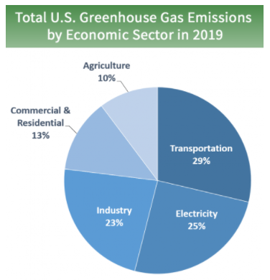

Source: <https://www.epa.gov/ghgemissions/sources-greenhouse-gas-emissions>

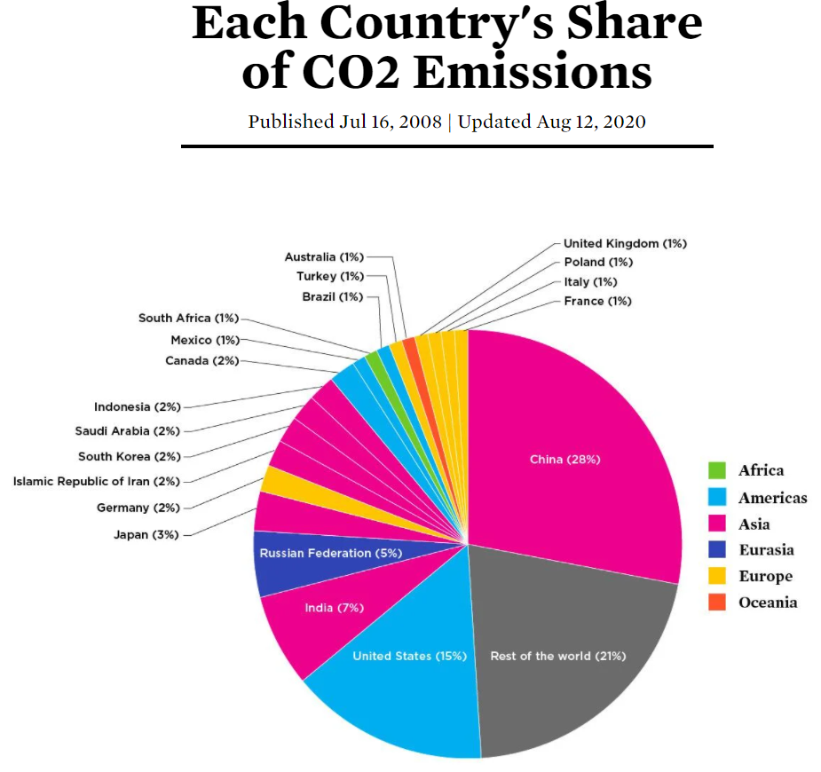

Source: <https://www.ucsusa.org/resources/each-countrys-share-co2-emissions>

